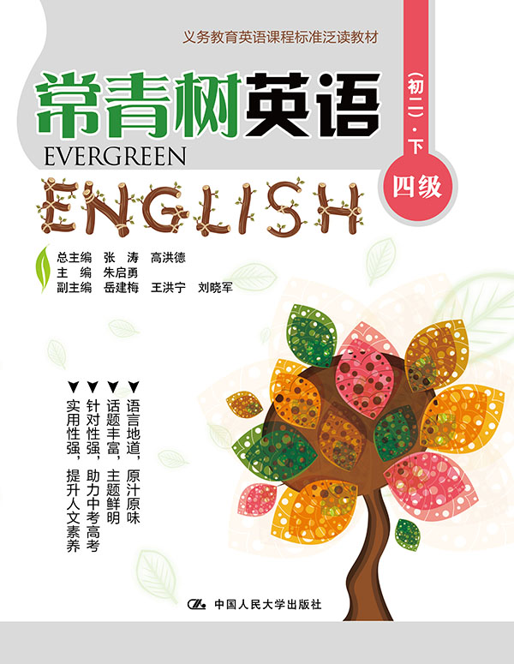
书名：常青树英语 四级（初二）·下
书号：978-7-300-21868-7
作者：高洪德 张涛 朱启勇
责任编辑：鞠方安 郭亚光
成品：177*228 页数：234
纸张：70克高白胶
装祯：平装
出版时间：2015年9月
定价：42.00元
出版社：中国人民大学出版社

- 本书卖点
- 语言地道、原汁原味
- 话题丰富、主题鲜明
- 针对性强、助力中考高考
- 实用性强、提升人文素养

◆ 读者定位
初中生

- 作者简介
高洪德，山东省教学研究室英语教研员、特级教师，中国教育学会外语教学专业委员会副理事长、山东省教育学会外语教学研究专业委员会理事长。
张涛，山东省教育学会外语教学研究专业委员会秘书长、山东省教学研究室英语教研员。

- 内容简介
《常青树英语四级（初二· 下）》是为初二学生量身定做的英语读物，它遵循课程标准精神，符合我国英语教学实际，难度上契合我国中学生英语学习的现状。全册以课程标准24个话题为主线，材料的选取与现行教材的话题相匹配，每分册标注相应的课标级别。每篇文章前面都有阅读导语，以引起学生的阅读兴趣，并配有生动有趣的插图。课后配有多样化的学习任务。

◆ 简要目录
Lesson 1 If Your Friend Betrays You, What Will You Do?
Lesson 2 What’s A Successful Language Learner Should Do?
Lesson 3 “My Toy”—Spinning Top
Lesson 4 Beautiful Hands
Lesson 5 Golf Is Popular In Japan
Lesson 6 My Father Was My Hero
Lesson 7 New Shoes for Winter
Lesson 8 Fear Matters
Lesson 9 Why Play Games?
Lesson 10 Improve Your Life
Lesson 11 The Climates of the United States
Lesson 12 Apple Unveils New Diverse Emesis
Lesson 13 What You See Is What You Get
Lesson 14 Everyone Can Make Contributions to Protecting Natural Resources
Lesson 15 How to Conquer A Bad Cold
Lesson 16 Family Travel Tips: Planning a Safari
Lesson 17 Never Lose Hope
Lesson 18 Experience Chinese Culture at “Chinese Bridge”
Lesson 19 Evening At Home
Lesson 20 A Positive Boy with His Baseball
Lesson 21 Kindness Rewarded
Lesson 22 Let’s Enjoy 4D Film!
Lesson 23 The Sun and the Moon
Lesson 24 The Internet and Its Impact
Lesson 25 To Love Oneself Is the Begin
Lesson 26 How to Travel In the Desert
Lesson 27 A Fantastic Big Sister
Lesson 28 How to Survive In a Burning House
Lesson 29 Grandma Moses and Me
Lesson 30 Chinese Sandwich
Lesson 31 What Is the Difference Between Weather and Climate?
Lesson 32 Mamma’s Present
Lesson 33 Street Markets Around the World
Lesson 34 Friendship of American Style
Lesson 35 Being a Clever Clothes Shopper
Lesson 36 National Wear Red Day
Lesson 37 Inventions Changed Our Life
Lesson 38 The Ice Hotel
Lesson 39 Things To Remember
Lesson 40 Global Warming
Lesson 41 All Green Today
Lesson 42 The Malls in the United States
Lesson 43 Foods at Important Moments
Lesson 44 Making Sense of the Ebola Virus
Lesson 45 Collecting Stickers
Lesson 46 It’s Never Too Late to Start Something New!
Lesson 47 Football: For Fun and Good Health
Lesson 48 Carrots
Lesson 49 A Musical Genius
Lesson 50 Foods That Give You Energy in the Morning
Lesson 51 To Stay Healthy in Summer
Lesson 52 Honoring a Father on Father’s Day
Lesson 53 Just for Today
Lesson 54 My Kindergarten Teacher, Mrs. White
Lesson 55 The Aging Population
Lesson 56 The Courageous Boy
Lesson 57 Save the Animals!
Lesson 58 Poor Davy
Lesson 59 A Letter for Help
Lesson 60 The Camel
Keys

◆ 上架建议
中学英语泛读读本

书摘
Lesson 7 New Shoes for Winter
Guidance
“You can’t have everything.” 你不可能总是那么幸运，也不可能拥有一切世界上最美好的东西。但只要你有一双善于发现的眼睛，就会发现你身边有很多美好而珍贵的东西。让我们看看Kate 在一次购物后体会到了什么？
Kate wanted to have new shoes for winter. She wanted four things from the new shoes. They must be warm and nice. They must be good for snow and ice. One more thing, they must be cheap.
Last Sunday, Kate went to John’ s Shop to buy new shoes for winter. It was in the east of the street. She looked around in the shop to look for the shoes for winter. There are many kinds of shoes for winter there. She liked some shoes, while she disliked others. Kate tried the shoes she liked. At last she chose one pair of shoes. They were warm and nice. The shop assistant said they were good for snow and ice. The most important thing was that they were really cheap. But she left the shop. She wanted to see more shoes in other shops. Kate told the shop assistant she would come back if she couldn’t find better shoes.
Then she went to many other shops along the street. In every shop she couldn’t find one pair of shoes that are nice, warm, cheap and good for ice and snow. She remembered the shoes in John’s Shop. Kate was tired and she didn’t want to go to other shops. So she went back to John’s shop. Here she found the best shoes and bought these shoes.
In the afternoon, Kate put on the new shoes and went for a walk with her best friend, Mary. After a few meters, she almost fell on the icy road. “Oh my God!” she said. The shoes were not good for ice. She had nice, good, warm winter shoes but they were not really good for ice. What could she do? She did not know. She talked about the shoes and about her bad luck all the time. Mary just listened in silence. She liked to listen because she was a good listener. Kate was still angry with the shoes but she was happy to have a good friend who was a good listener. “You can’t have everything.” she said to herself.

